**Exp 1. V-I Characteristics of a P-N Junction Diode**

**Date:**

**Aim:**

To determine the knee voltage and dynamic resistance of a pn junction diode

**Apparatus required:**

pn junction diode 1N4001j

Voltmeter (0-1) V, (0-10) V

Ammeter (0-50) mA, (0-100) A

Resistor 1 kΩ

LTSPICE

**Theory:**

The diode is a device formed from a junction of n-type and p-type semiconductor material. The lead connected to the p-type material is called the anode and the lead connected to the n-type material is the cathode. In general, the cathode of a diode is marked by a solid line on the diode.

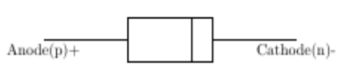

**Fig.1 Cross section**

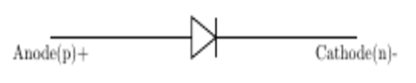

**Fig.2 Symbol**



In Equation the applied voltage V can be positive or negative, V = Vf or V = -Vr. When V is positive and greater than a few kT>q (kT>q = 0.0259 V at room temperature), the exponential term is much greater than unity. The current thus increases exponentially with forward bias. When V is negative (reverse bias), the exponential term approaches zero and the current is -I0, which is in the n to p (negative) direction. This negative generation current is also called the reverse saturation current. Current flows relatively freely in the forward direction of the diode, but almost no current flows in the reverse direction

**Circuit Diagram**

**Forward bias (Redraw)**

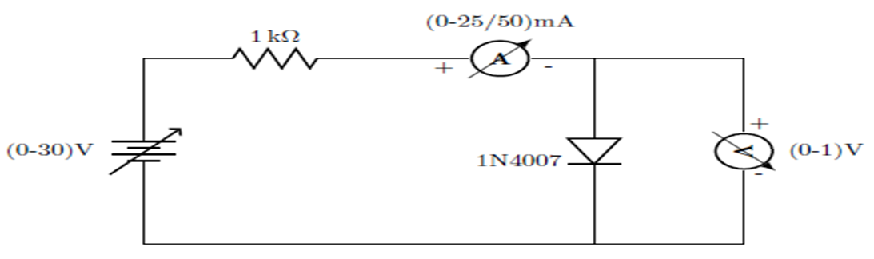

**Reverse Bias**

**……**

**Model Graph**

**Forw ard bias**

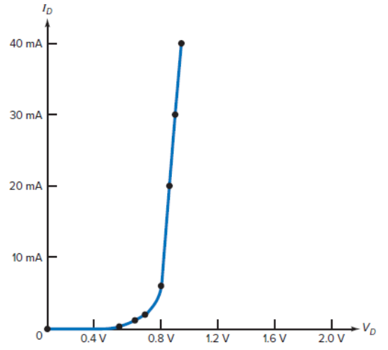

**Reverse Bias**

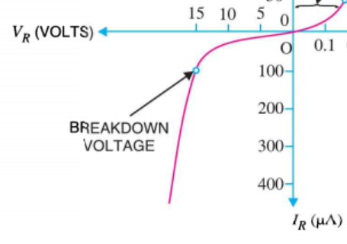

**Observation**

**Forwrad bias**

|  |  |  |
| --- | --- | --- |
| **S.No** | **Voltage (V)** | **ID (mA)** |
|  |  |  |
|  |  |  |
|  |  |  |
|  |  |  |

**Reverse bias**

|  |  |  |
| --- | --- | --- |
| **S.No** | **Voltage (V)** | **ID (μA)** |
|  |  |  |
|  |  |  |
|  |  |  |
|  |  |  |

**Inference**